Data at large  
the Process book

CS171 Visualization project fall 2017  
By Cindy zhao, ziqi guo, michelle ho

# Project overview & motivation

Internet has become an integral part of modern life. As we take advantage of the conveniences that the digital age offers, we are becoming increasingly vulnerable to cybercrimes such as fraud and identity theft. Inspired by the recent data breach incident from Equinfax that affected over 143 million people in the United States, we would like to investigate and understand the increasingly serious issues with data breaches, use visualizations to raise the public’s awareness in monitoring the safety of their personal data, and offer proactive approaches in cybersecurity protection.

The project is consisted of 4 main parts: We begin by describing the rise of the Internet age and transitioning to a brief background of hackers and why they hack. Subsequently, we show selected incidents of company data breaches to make the point that the data we implicitly entrusted to companies are susceptible to cyberattacks. The consequences of these data breaches are often cybercrimes on an individual level, so we follow up by visualizing identity theft trends and the time needed to resolve it. Lastly, we aim to make suggestions on creating a safer online existence.

# project goals & Questions

The main goal of this project is to use visualizations to raise the public’s awareness in monitoring the safety of their personal data, and offer approaches in cybersecurity protection. To do so, we would like to explore the following questions:

1. **Concerning the internet and the hackers:**
   1. How has internet usage in the U.S. evolved over time?
   2. Who are hackers? Why do they hack?
2. **Concerning the data that we entrust to companies:**
   1. How secure is the data we entrust to companies while we use the internet?
   2. Are incidents of company data breaches increasing over time?
   3. Which type of breach are companies most susceptible to?
   4. How sensitive are the data being breached (e.g. contents of emails, credit card information, or social security)?
   5. Are there certain types of organization more prone to certain type of data breaches?
3. **Concerning the consequences of data breaches**:
   1. What is the trend of identity theft in each state over time?
   2. How long does it take to resolve identity theft issues?
4. **Concerning creating a safer online existence:**
   1. Are we spending more to improve cybersecurity?
   2. What are the steps we can take to improve the safety of our online existence?

# project tasks

1. **Data acquisition and wrangling:** Data are acquired from the sources listed in the next section, Questions & Data Sources. Most of the datasets are fairly clean, so we expect minimal data cleaning in this step. However, many of the datasets come in the form of .xlsx files with multiple excel sheets per data file. Therefore, we would need to convert these files into .csv or .json files before we can use them.
2. **Visualization and interactivity implementation:** We plan to implement 10 visualizations, and the details of these visualizations are shown in Section 4: Sketches & Features. As the sketches of these visualizations will show, the viz are not all equally complicated. We plan to divide the work based on complexity not on number of visualizations. We also plan to work on the more difficult visualizations as a group.
3. **Acquisition/production and compilation of texts for storytelling**: We expect the most textual information in Part 1: Rise of the internet age and Part 4: Efforts to combat cybersecurity issues. We also plan to add some annotation to our visualizations to make the point of each visualization pop out.
4. **Website design and implementation:** Our website will follow an interactive slideshow format with navigation tabs on the top. The exact design and implementation strategies will be discussed and determined as a group.

# questions & data sources

We realized early on that in order to fulfill our full story arc, we would need to find multiple sources of data, each answering a specific question. Therefore, in this section, we present the questions asked and the related data sources by the part of the project outline (see above) to which the questions and data belong.

**Part 1: About the internet and the hackers:**

* Question: How has internet usage in the U.S. evolved over time?
  + Data: Individuals using the Internet (% of population) (<https://data.worldbank.org/indicator/IT.NET.USER.ZS)>
  + Data: Mobile cellular subscriptions (per 100 people) (<https://data.worldbank.org/indicator/IT.CEL.SETS.P2)>
* Question: Who are hackers? Why do they hack?
  + Data: Textual infoviz

**Part 2: Trends in Company Data Breaches**

* Question: Are incidents of company data breaches increasing over time?
* Question: Which type of breach are companies most susceptible to?
* Question: How sensitive are the data being breached (e.g. contents of emails, credit card information, or social security)?
* Question: Are there certain types of organization more prone to certain type of data breaches?
  + Data: Company data breach records from 2004 to 2017 ([https://docs.google.com/spreadsheets/d/1Je-YUdnhjQJO_13r8iTeRxpU2pBKuV6RVRHoYCgiMfg/edit - gid=322165570)](https://docs.google.com/spreadsheets/d/1Je-YUdnhjQJO_13r8iTeRxpU2pBKuV6RVRHoYCgiMfg/edit#gid=322165570))

**Part 3: Consequences of Data Breaches (Identity Theft)**

* Question: What is the trend of identity theft in each state over time?
  + Data: Complaints of identity theft by state from 2008 to 2016 (<https://www.iii.org/table-archive/21319)>
* Question: How long does it take to resolve identity theft issues?
  + Data: Time spent on revolving identity theft (<https://www-statista-com.ezp-prod1.hul.harvard.edu/statistics/441740/time-taken-us-travelers-resolved-identity-theft/)>

**Part 4: Recommendations to Combat Cybersecurity Issues**

* Question: What are the steps we can take to improve the safety of our online existence?
  + Data: Textual information

# Visualization Sketches & features

**Part 1: Rise of the Internet Age**

**Visualization 1.1 – Increase in internet use**

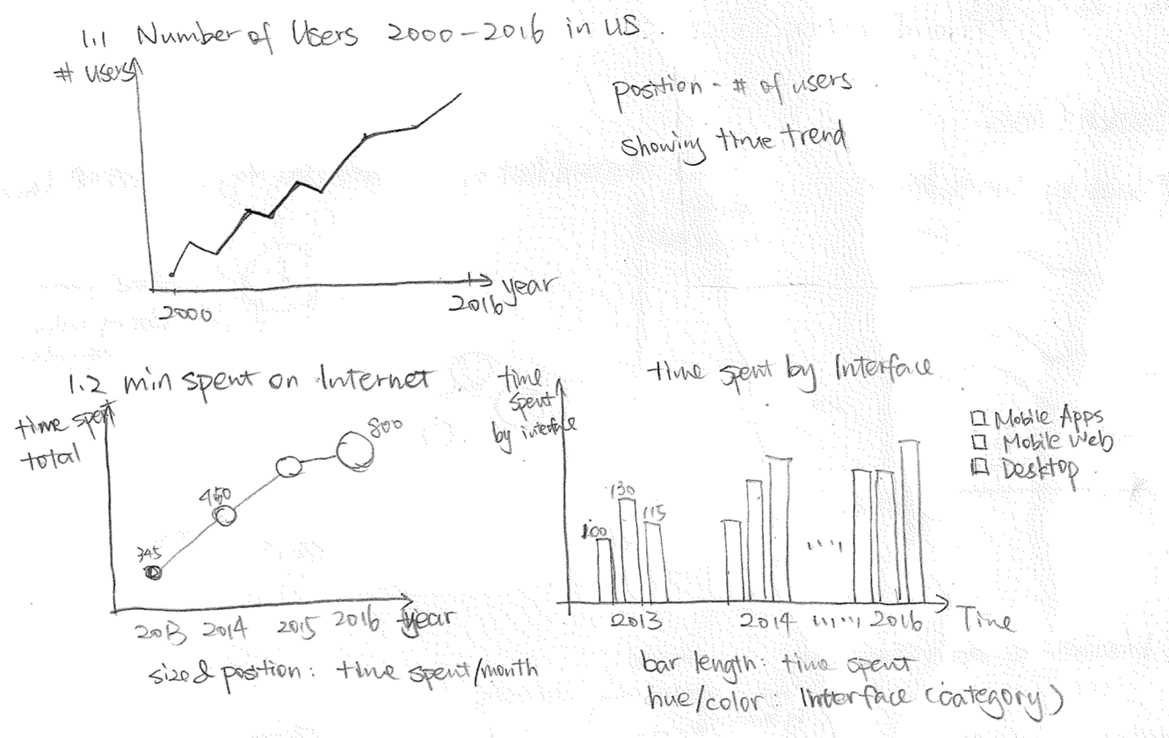

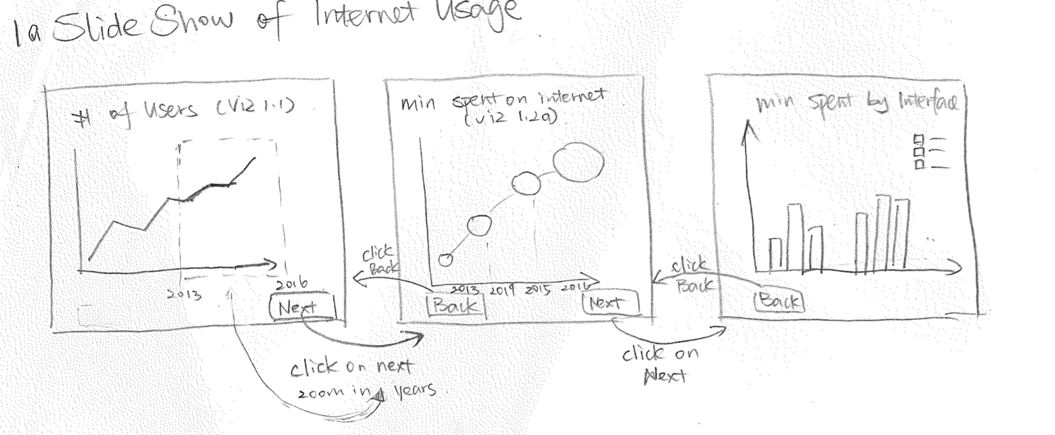

* Must-have Features:
  + Able to visualize trend of internet usage by different metrics (number of users, time spent)
  + Able to pinpoint major concerns of internet usage
  + Able to tell a compelling story by linking the visualizations together into an interactive slideshow
  + Able to show detailed statistics on hovering
* Good-to-have Features:
  + Able to break down by types of internet activities age groups, for more in-depth analysis
  + Support lower-level filtering by age groups and internet activities to manipulate the views

**Visualization 1.2 – Top concerns about internet usage**

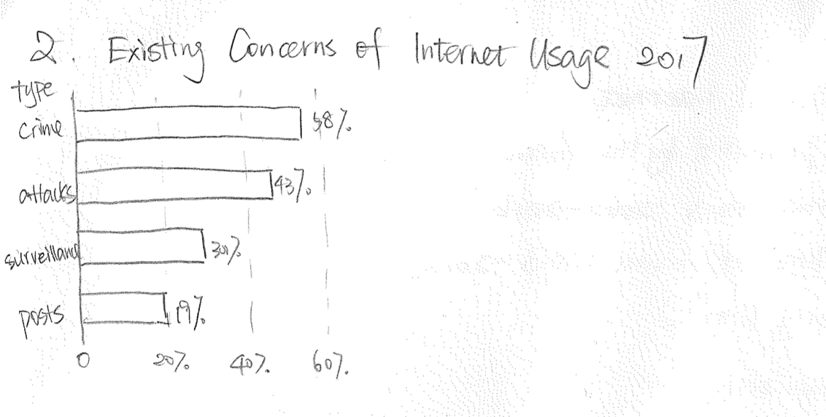

**(Good to have) Visualization 1.3: Most popular online activities in 2017**

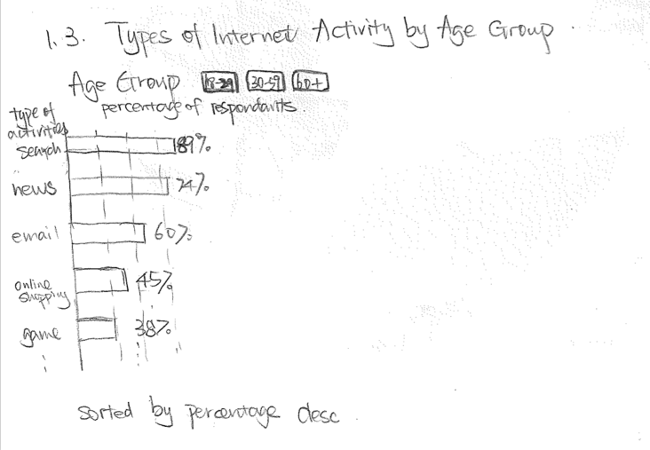

This is a good-to-have visualization because it only adds breadth to our background but is not essential for setting up the problem.

**Part 2: Trends in Company Data Breaches**

**Visualization 2.1: Trends in company data breaches**

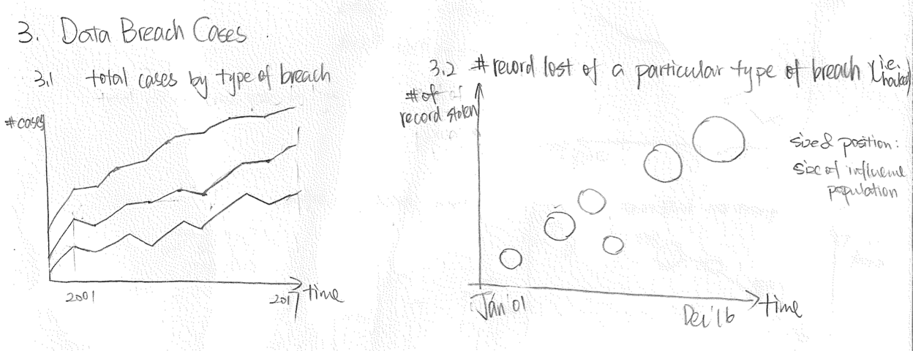

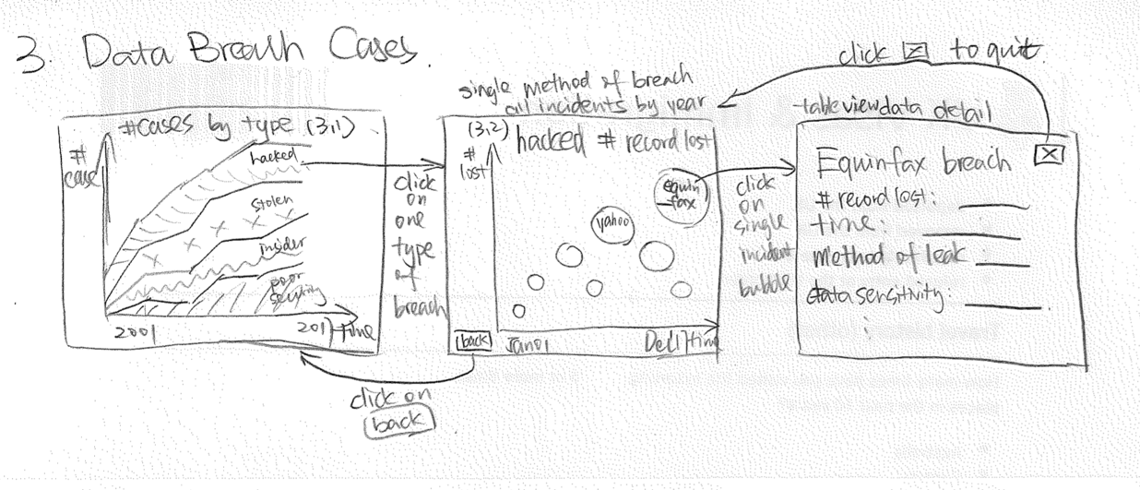

* Must-have Features:
  + Linked view for stacked area chart and bubble chart
  + Able to select a type of breach to filter the bubble chart
  + Able to select on the bubbles to see textual story of each data breach incident
* Good-to-have Features:
  + Able to select different variables to display for the stacked area chart (e.g. data sensitivity, organization type)

**Visualization 2.2: Data breach case details**

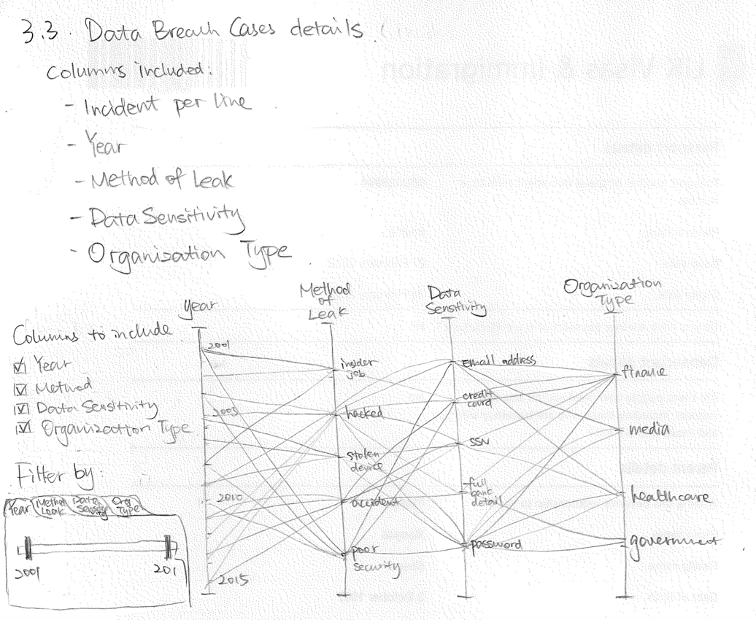

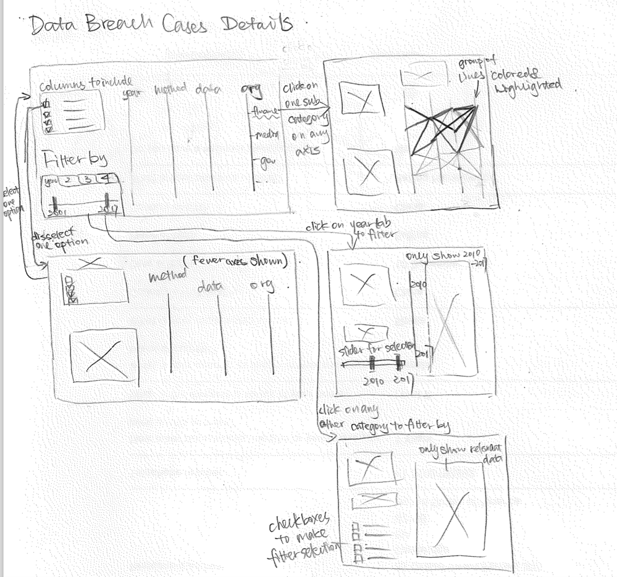

* Must-have Features:
  + A parallel-axis chart to visualize each case by its associated year, method of leak, data sensitivity and organization type.
  + Support filtering of each axis to highlight certain cases.
* Good-to-have Features:
  + Allow for filtering categories to be placed on the axis.

**Part 3: Consequences of Data Breaches**

**Visualization 3.1: Trends in identity theft**

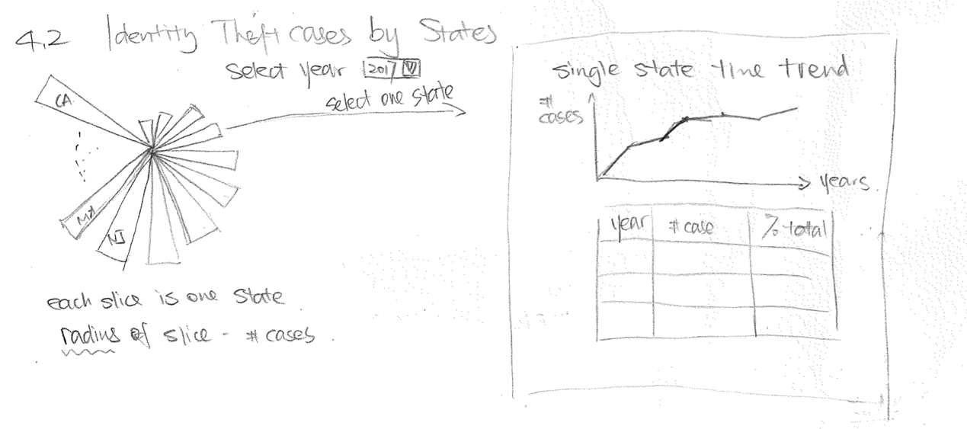

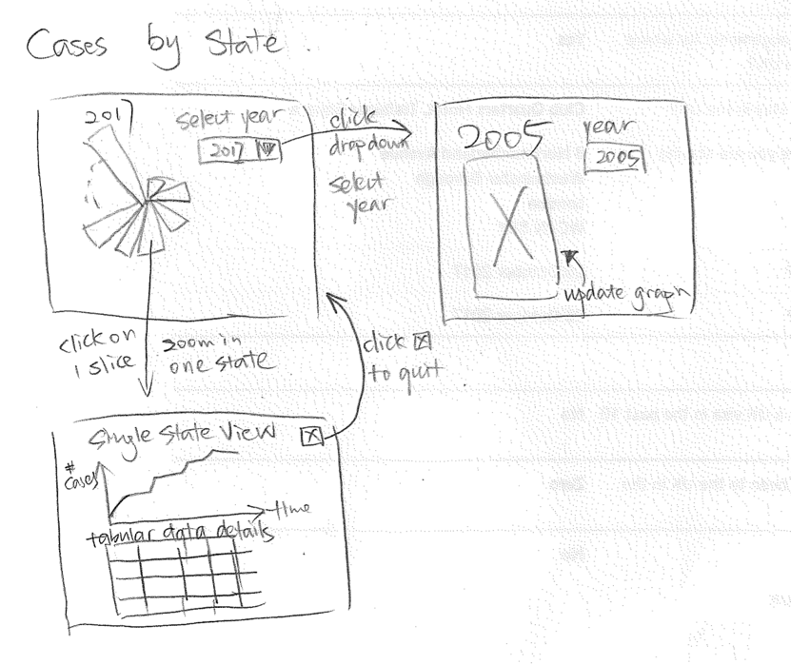

* Must-have Features:
  + A polar area chart showing number of identity theft cases by states in the US.
  + On clicking of each area, change view to a line plot showing time series for the selected state as well as a table with detailed statistics
  + Support filtering by year

**Visualization 3.2: Time spent on resolving identity theft cases**

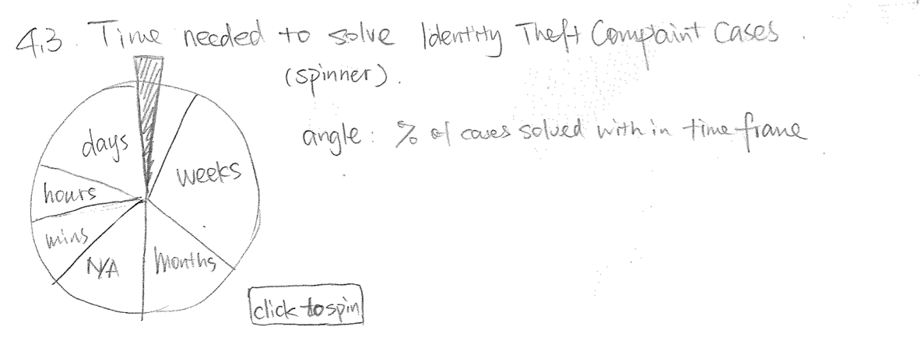

* Must-have Features:
  + Click to spin

**(Good to have) Visualization 3.3: Trends in identity theft by state**

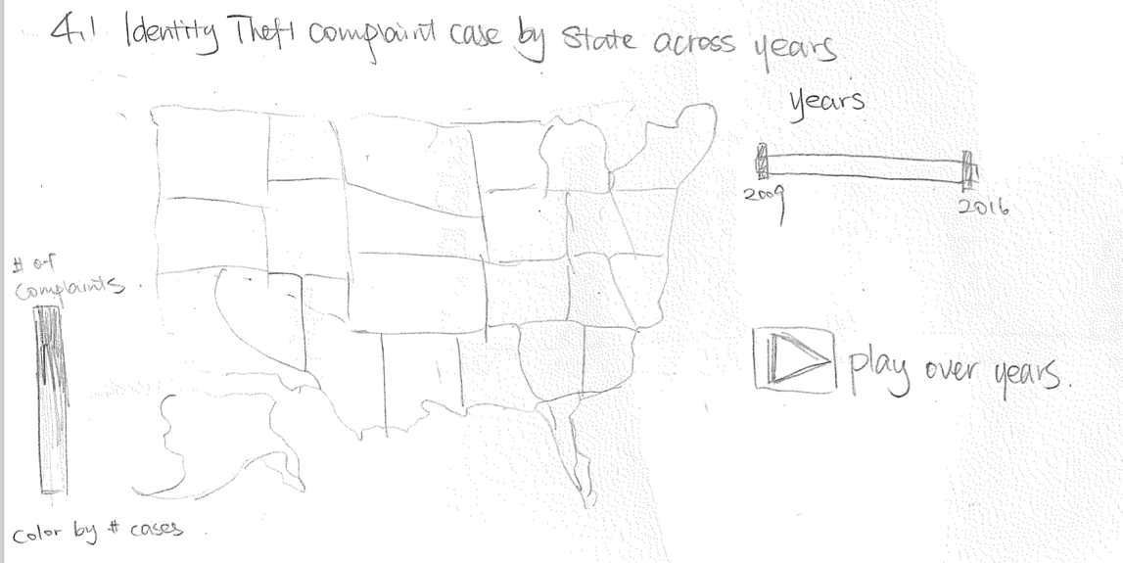

This is a good to have visualization because it contains information already presented in the polar area chart (Visualization 3.1). This is just a different treatment of the same information

* Good-to-have Features:
  + Allows filtering by years, and animating choropleth over years

**Part 4: Efforts to Combat Cybersecurity Issues**

**Visualization 4.1: Trends of spending on cybersecurity in the U.S.**

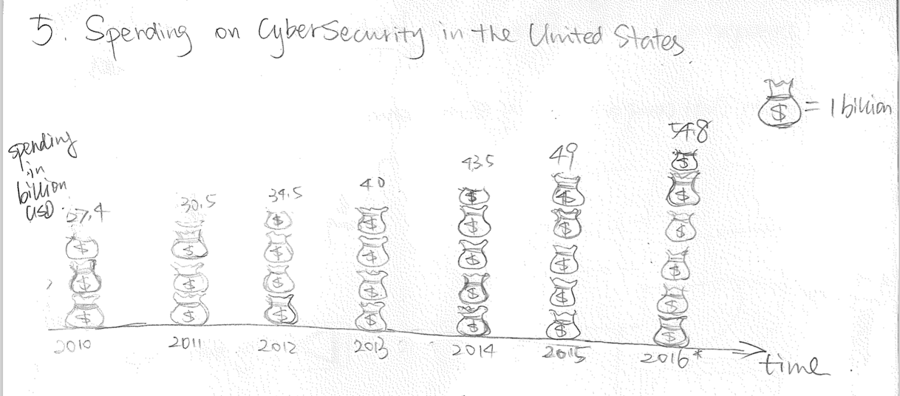

* Must-have Features:
  + Visualize spending on cybersecurity over the years
* Good-to-have Features:
  + Use infographics to tokenize dollars to enhance visual impact

# website Sketches







# Timeline



# Team roles

We will make sure all team members participate in all stages of the project, and programmed significant amount of the website. The high-level focus of each member is shown below:

|  |  |
| --- | --- |
| Member | Roles |
| Michelle | * Setting up and organizing the github repo * Overall website layout |
| Cindy | * Draw sketches and organize visualization/interaction ideas * Evaluate implementations and project targeting |
| Ziqi | * Maintain process book * Wrangle data to useable format |

We aim for even split on implementation work. More detailed task allocation will be done on group chat on a weekly basis.

# Design evolution

As we explored the dataset further, we made several adjustments to the types of visualizations we want to include in the website.

**Change 1: Visualization 1.1 – Increase in Internet Use**

**Before change:**



**After change:**

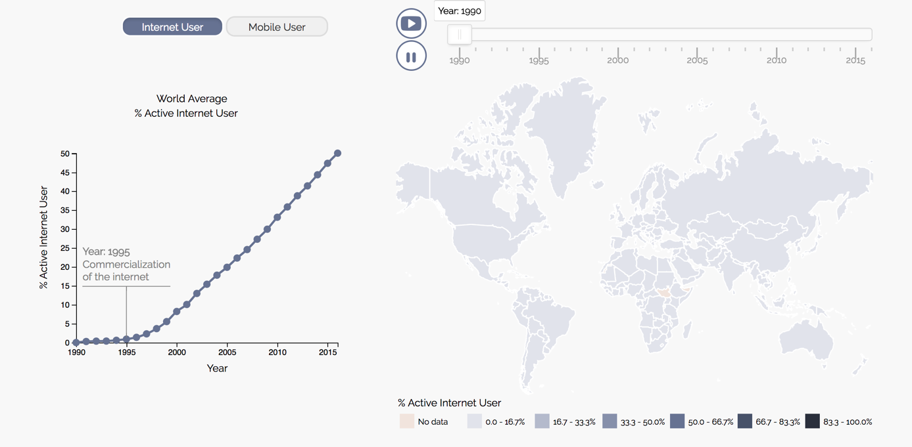

We replaced the original idea of a slideshow with three visualizations to this one visualization with this arrangement. The left chart can be toggled between Internet User and Mobile User. On the right, a choropleth of active internet user will be animated from 1990 to 2015 to instantly draw attention from the readers.

**Change 2: Visualization 3.1 – Trends in Identity Theft**

**Before change:**



**After change:**

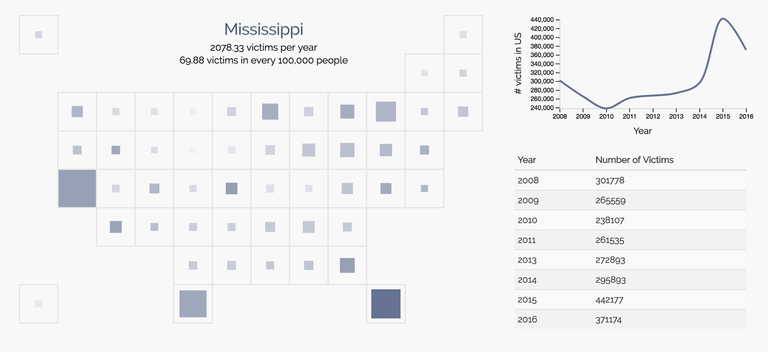

One main drawback of a polar area chart is that readers will be visually draw to the most outstanding 3-4 slices and will potentially skip over the smaller slices. Especially when we have 50 states to visualize, the polar area chart might not be the most suitable type of graph. Instead, we used a modified version of a choropleth chart, where we represent each state not based on its actual geographical shape but squares with uniform areas. This removed the effect of states’ varying sizes might have on how readers will comprehend the graph.

Here the size of the inner square represents the average number of victims per year for each state, and the color intensity (not fully implemented here) will encode the number of victims per 100000 population.

By clicking on to each area, a line chart and table corresponding to the state will be displayed to the right of the map to see the trend over the years for the selected state.

**Change 3 (Innovative View):**

**Visualization 3.2 – Time Spent on Resolving Identity Theft Cases**

**Before change:**



**After change:**

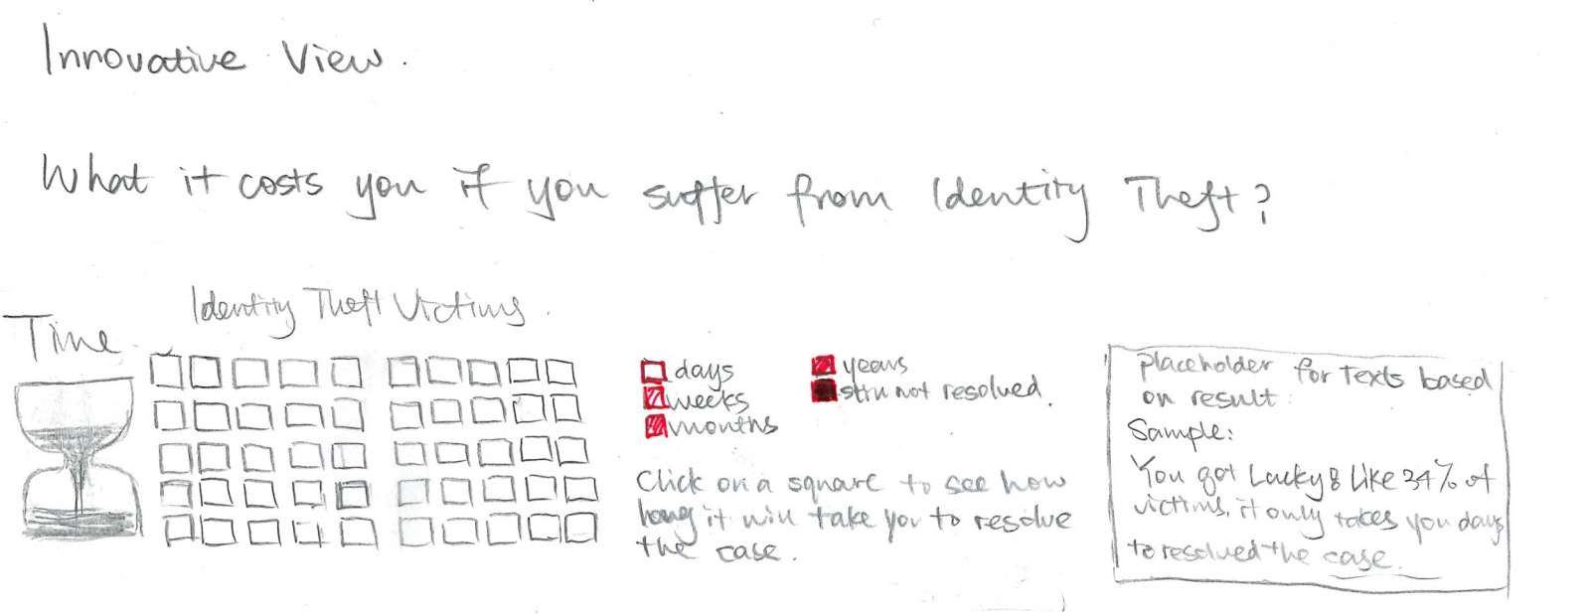

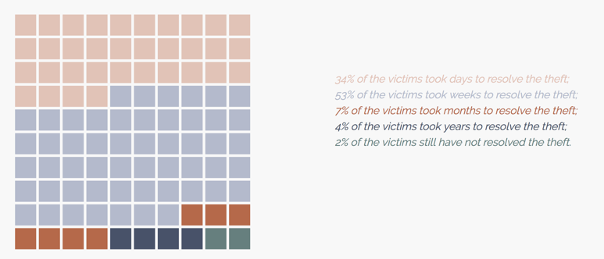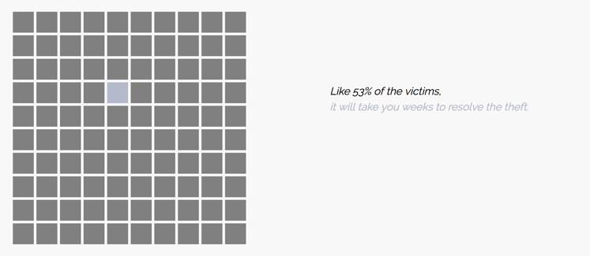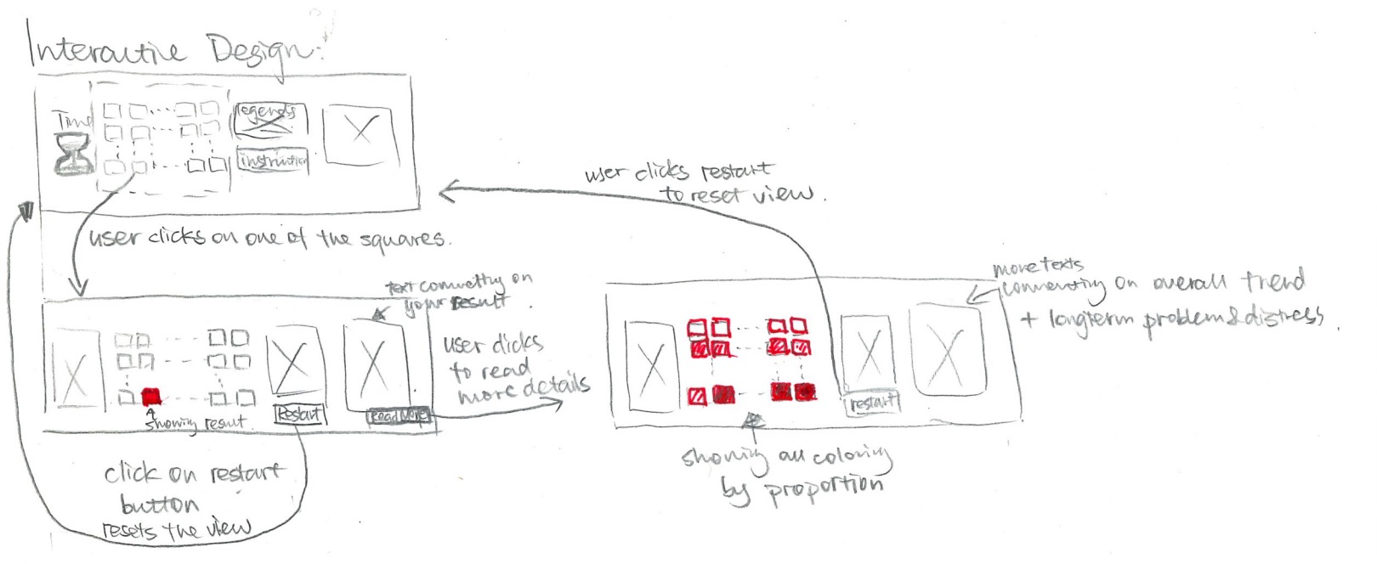

The new design is a more innovative way to get the audience involved. The audience will be prompted to click on a square, and then the square will reveal its color, representing a category of time spent on resolving the identity theft. Then, all the squares will be flipped automatically to show the overall distribution.

**Change 4: Visualization 1.2**

**Before change:**



**After change:**

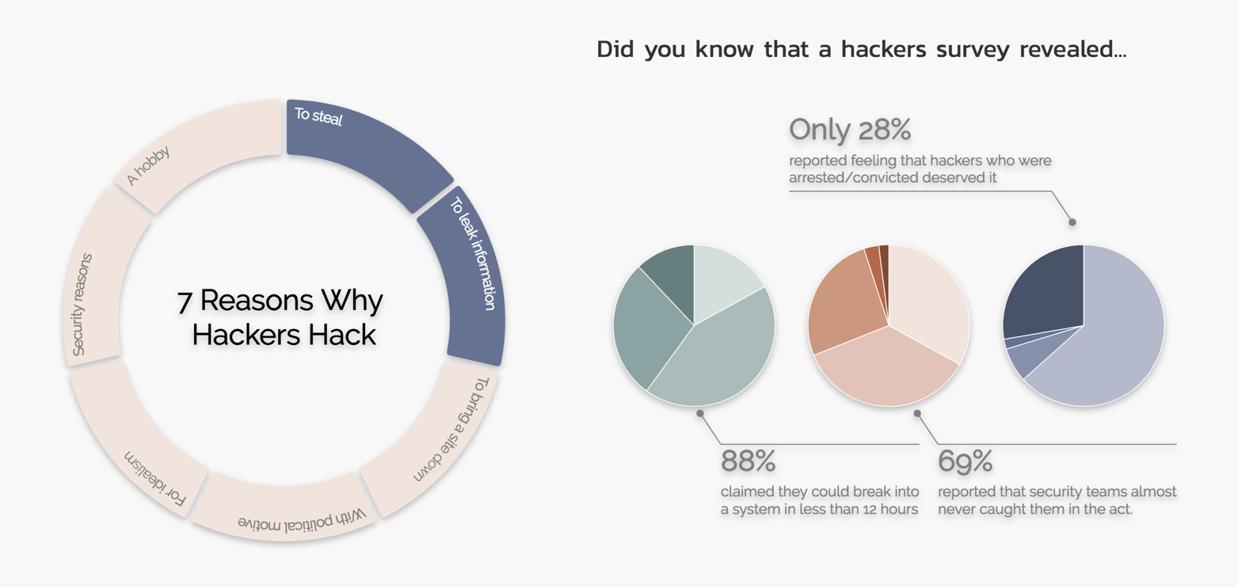

The original plan was to visualize people’s existing concerns about internet usage. However, we feel that this isn’t the logical step here, as if people already realize the threat of cybercrimes, then the objective of this website to raise awareness is somewhat unfounded. Instead, we decided to introduce a new section to introduce hackers, their motivations, and some rarely known statistics about hackers. This section serves as a transition from the growth of internet to the next chapter, which is company data breaches.